**HISTORY OF DIAMOND SEAL FACE TECHNOLOGY AND MECHANICAL SEAL APPLICATIONS**

The ability to provide the benefits of natural diamond to mechanical seals has become a reality in the last few decades.

Diamond’s extreme hardness, chemical resistance and high thermal conductive have always been very desirable properties for mechanical seal faces. However, the fabrication of diamond with the proper surface metrology and form has only been available since advances were made in the technical community in the 1990s.

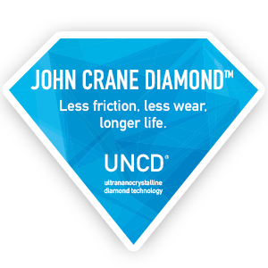

These advances enabled diamond to be grown using a chemical vapor deposition (CVD) processes in a manner that eliminated the previous requirements to grind or finish the diamond-treated face. CVD diamond is now routinely grown on mechanical seal rings that, without post-deposition processing, matches the specifications of flatness, roughness and overall form, and provides drop-in benefits to existing seal designs.

The improvements in diamond processing were largely led by developments in government and university laboratories. The performance of these initial laboratory-scale demonstrations spawned investment and commercial growth that focused on developing commercial-scale processes and the appropriate quality inspections to support commercial demand.

Today, thousands of diamond-treated mechanical seal rings are being put into a wide range of service every month. Mechanical seals incorporating diamond are providing solutions to many applications ranging from poor lubricating conditions found in hot water, entranced gases, and light hydrocarbons to strong chemical and abrasive applications found in mineral processing and mining.

Diamond-treated seal rings provide a robustness and durability that enables them to often overcome upset conditions that can occur due to unplanned operational issues.

As diamond processing continues to improve seal performance, and the reduced overall cost of ownership benefits provided by diamond becomes better documented, one of Earth’s hardest natural materials will continue its penetration and acceptance as a viable material for mechanical seal faces.

Learn more about John Crane Diamond™ and the advantages of harnessing the properties of one of Earth’s hardest substances.